Merge Conflict
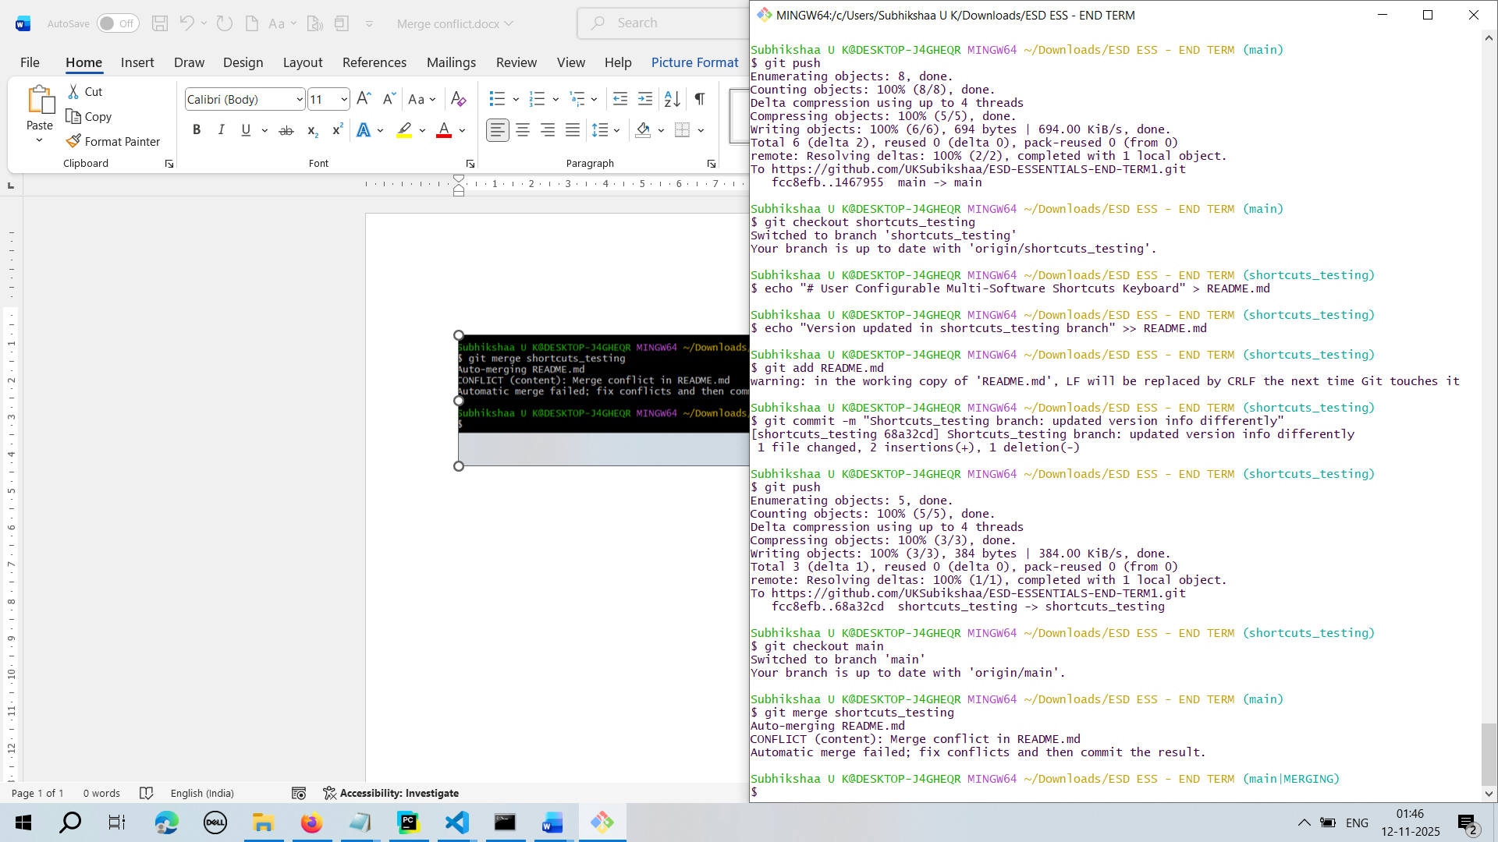

To confirm Merge Conflict
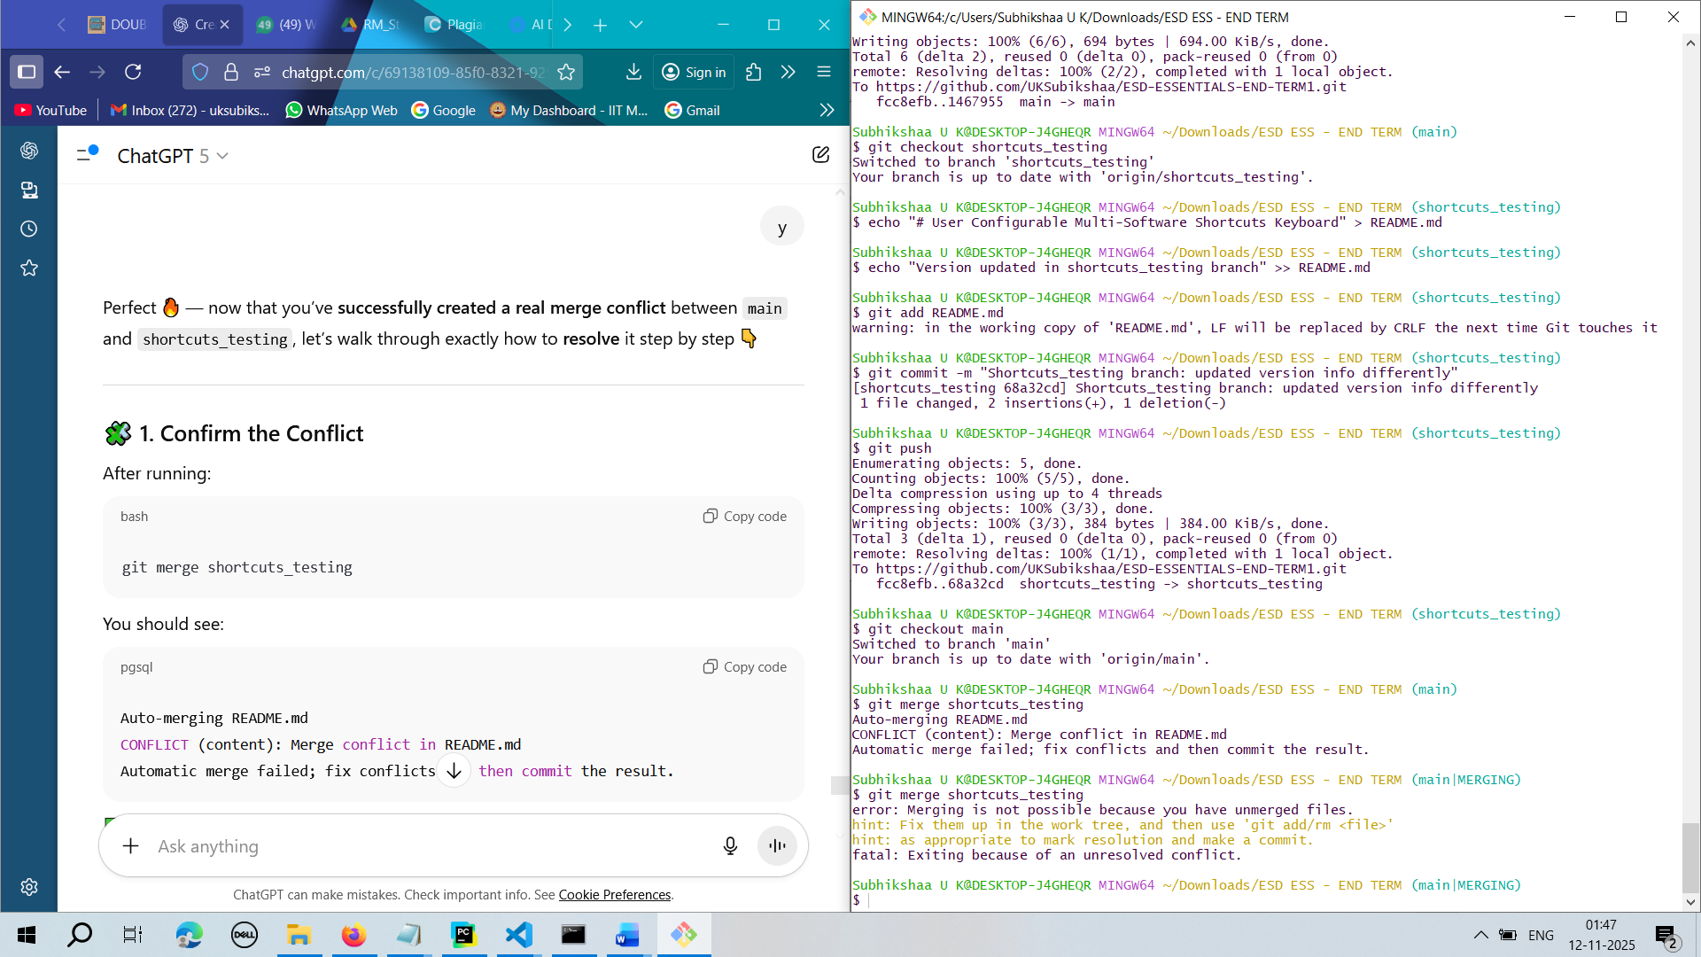

To Check which file has merge conflict
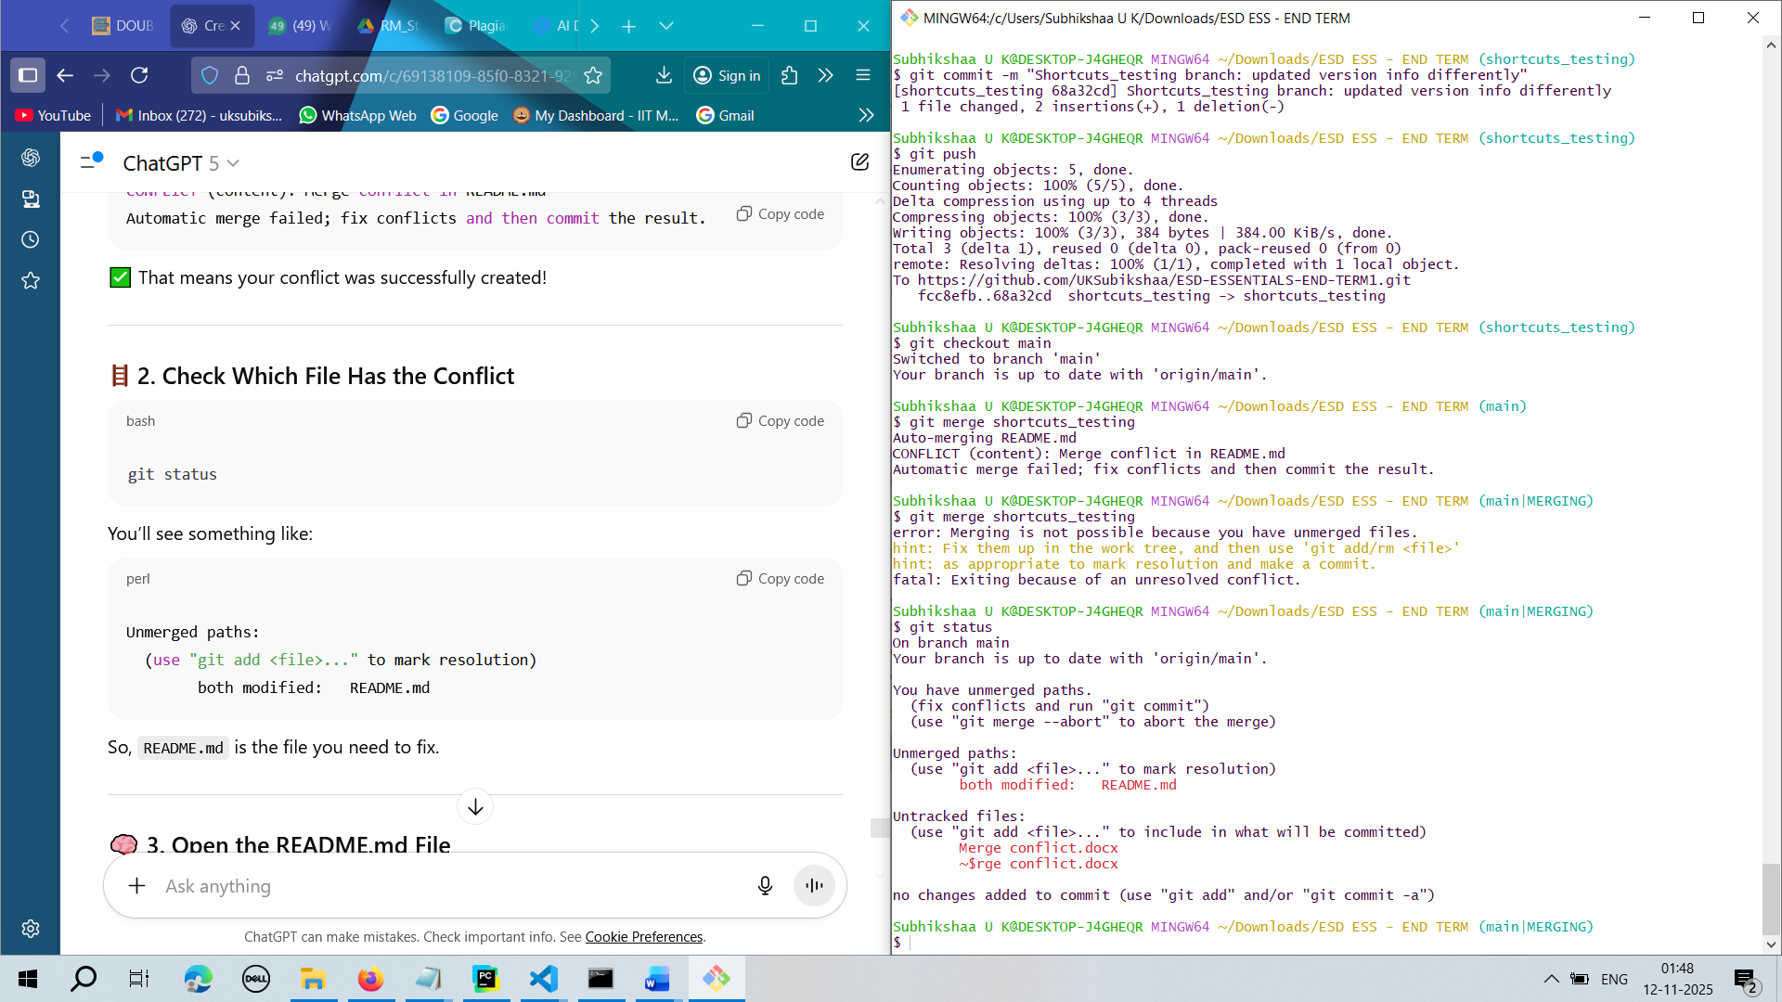

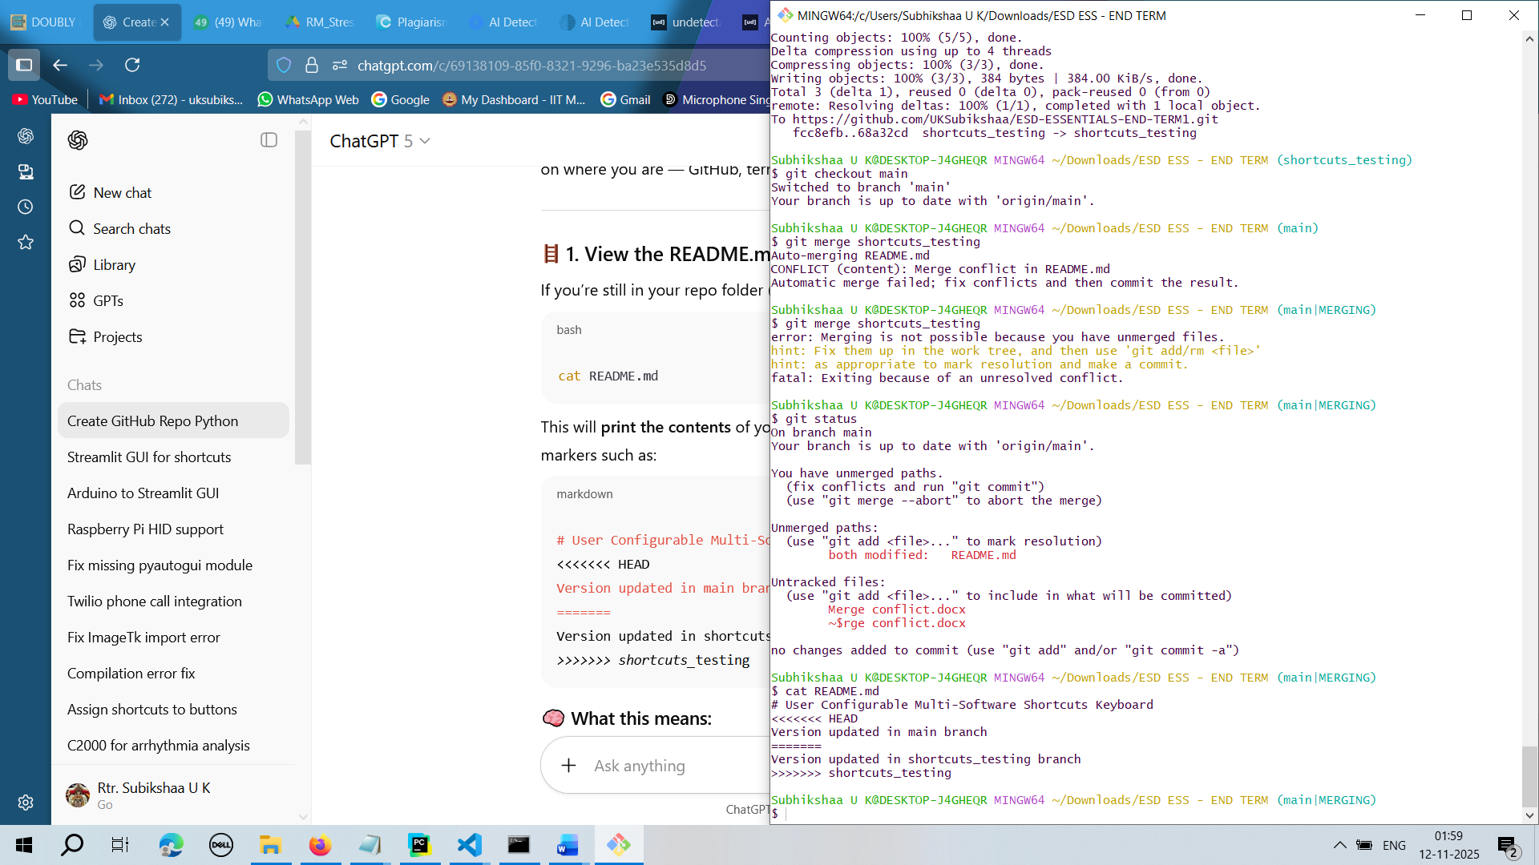
<<<<<<< HEAD → shows what’s currently in your main branch (the branch you’re merging into).
======= → divides the two conflicting versions.
>>>>>>> shortcuts_testing → shows the conflicting version from the other branch.
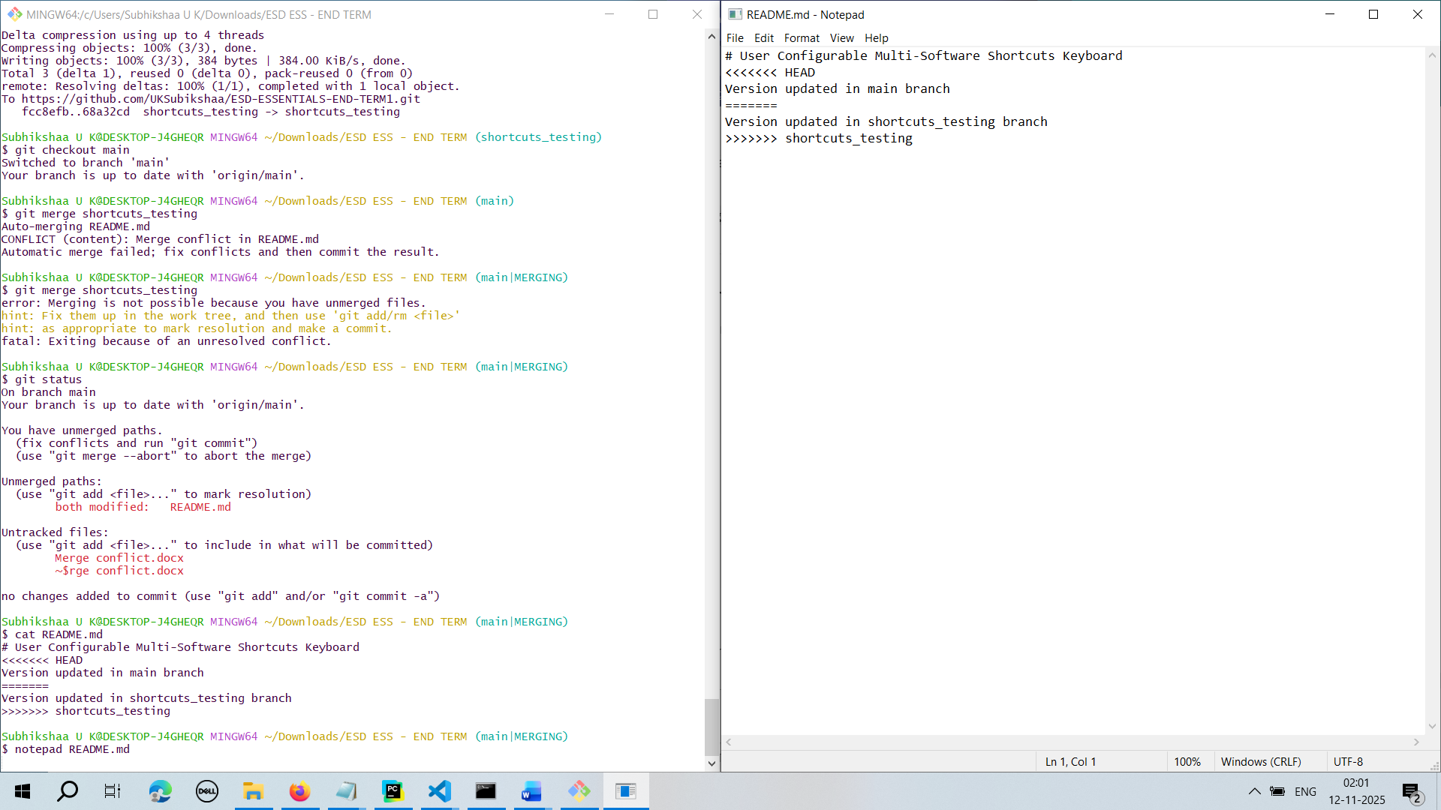

Resolved the Merge Conflict and he staged the changes in README.md
